User Guide — The Brainstormer

The Brainstormer — User Guide

Overview
The Brainstormer is a structured thinking partner that helps you explore ideas, clarify problems, and converge on solutions. It features a chat interface paired with a live "Thinking Canvas" that organizes your brainstorming session into actionable components.
──────────────────────────────────────────────────

Interface Layout
The page is divided into 2 panels:
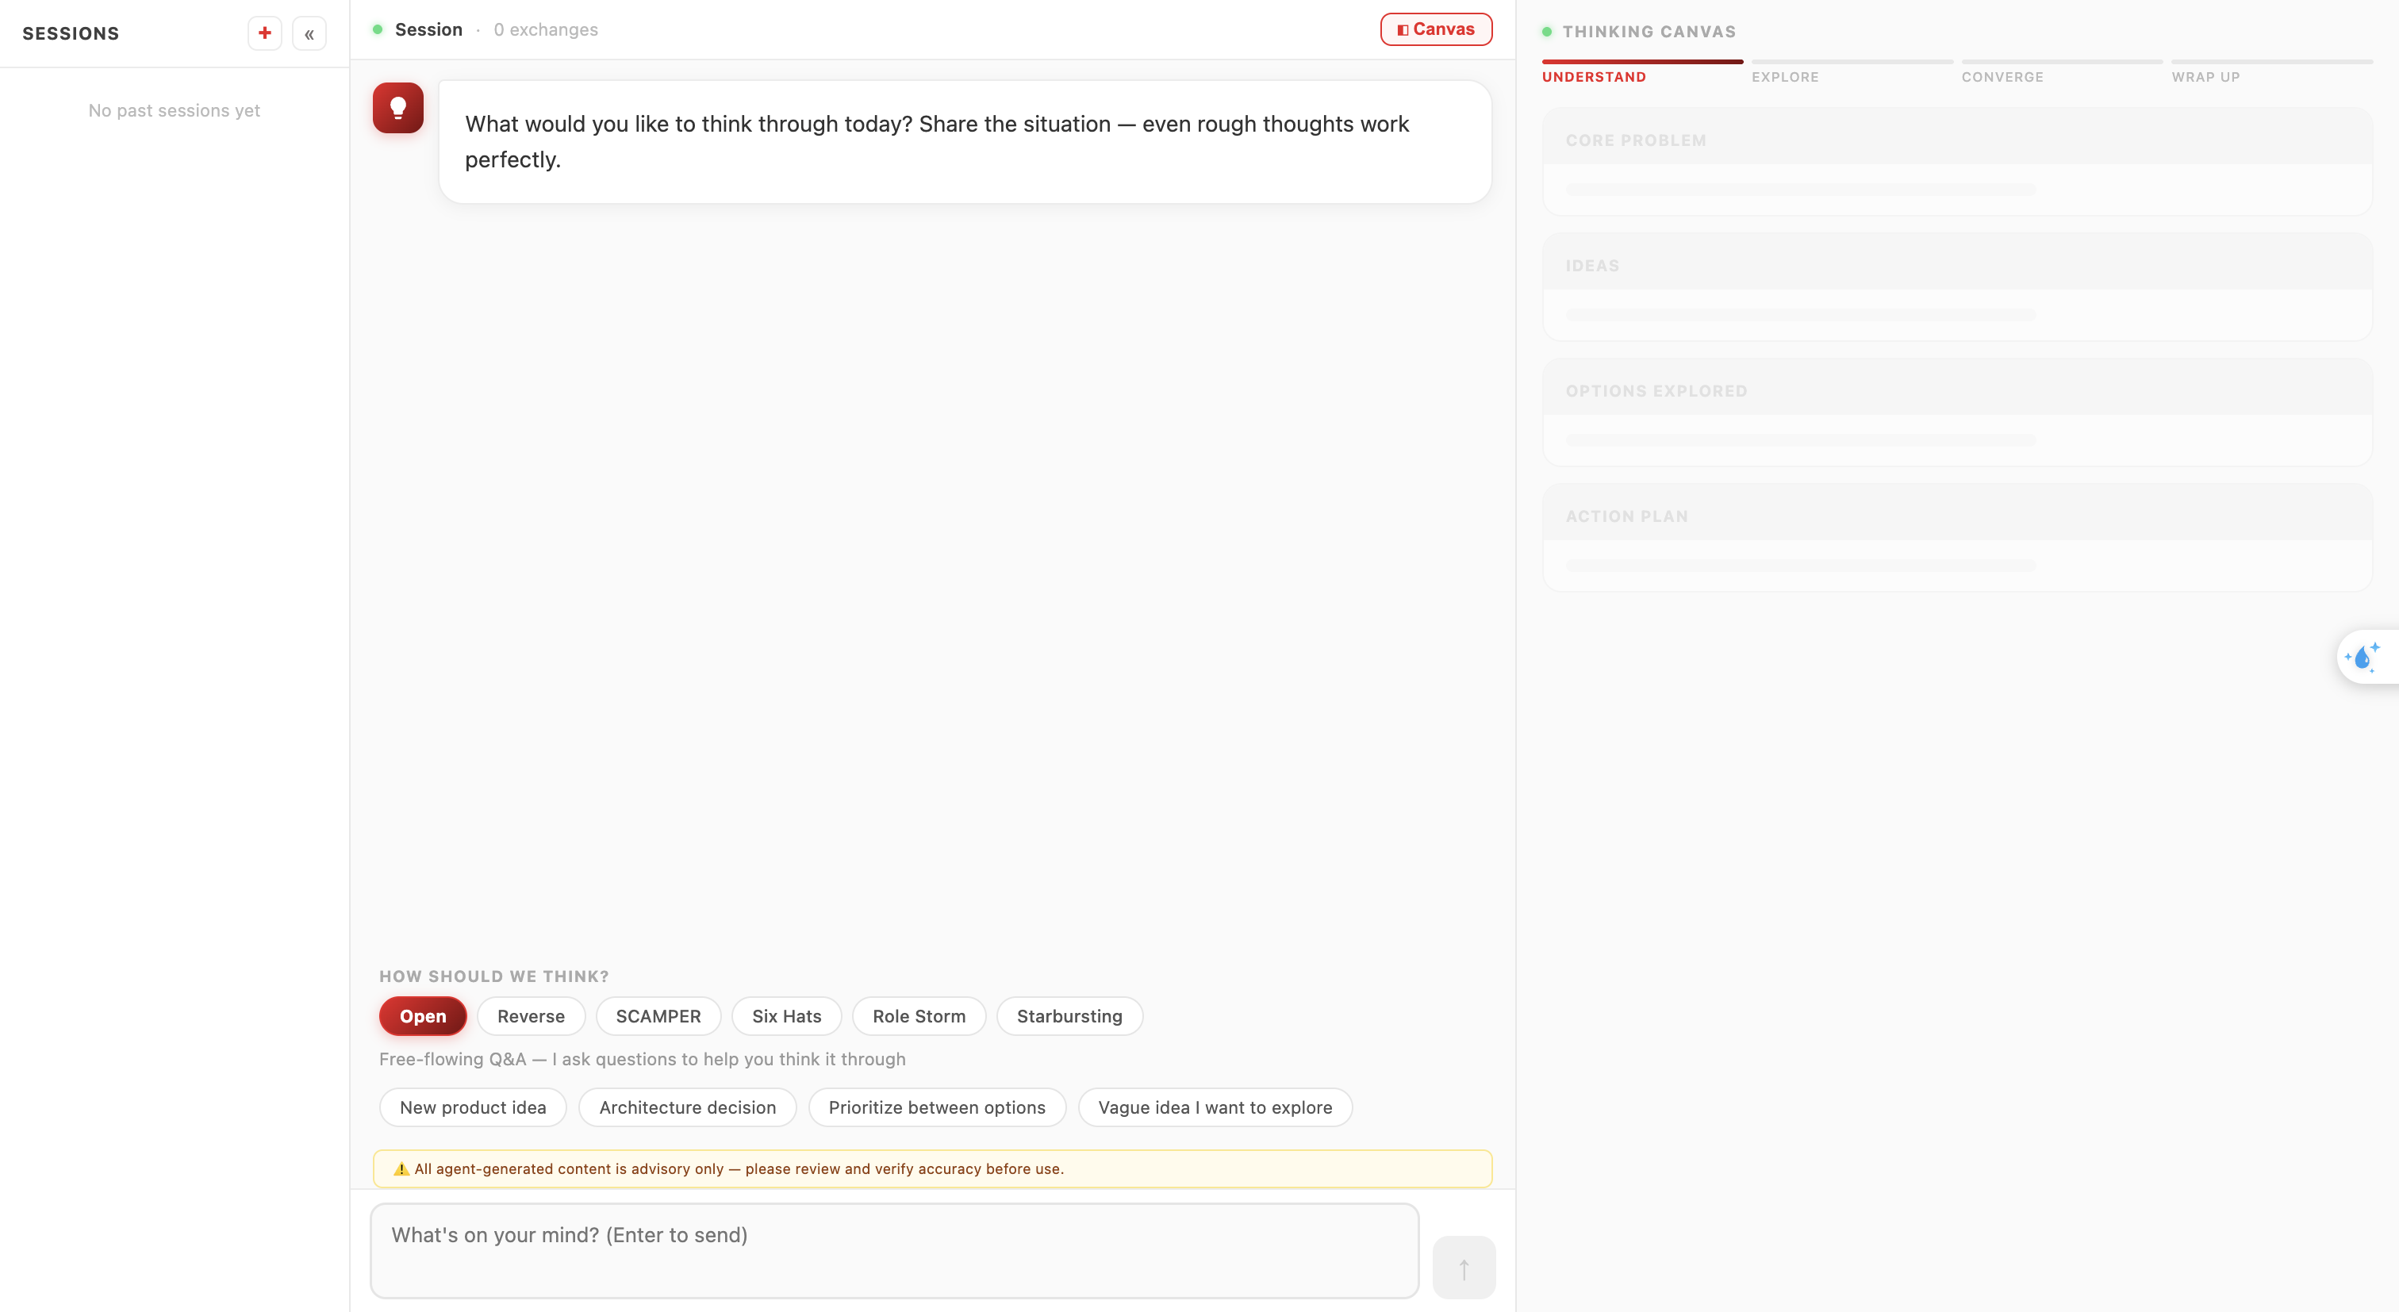
Panel | Purpose
Left (58%) | Chat conversation with the AI
Right (42%) | Thinking Canvas — structured output
──────────────────────────────────────────────────

How to Use

Step 1: Start a Conversation
Type your idea, problem, or question in the input bar at the bottom. You can also click one of the hint chips for inspiration: - "New product idea" - "Architecture decision" - "Prioritize between options" - "Vague idea I want to explore"
Press Enter to send (Shift+Enter for new line).

Step 2: Engage in Dialogue
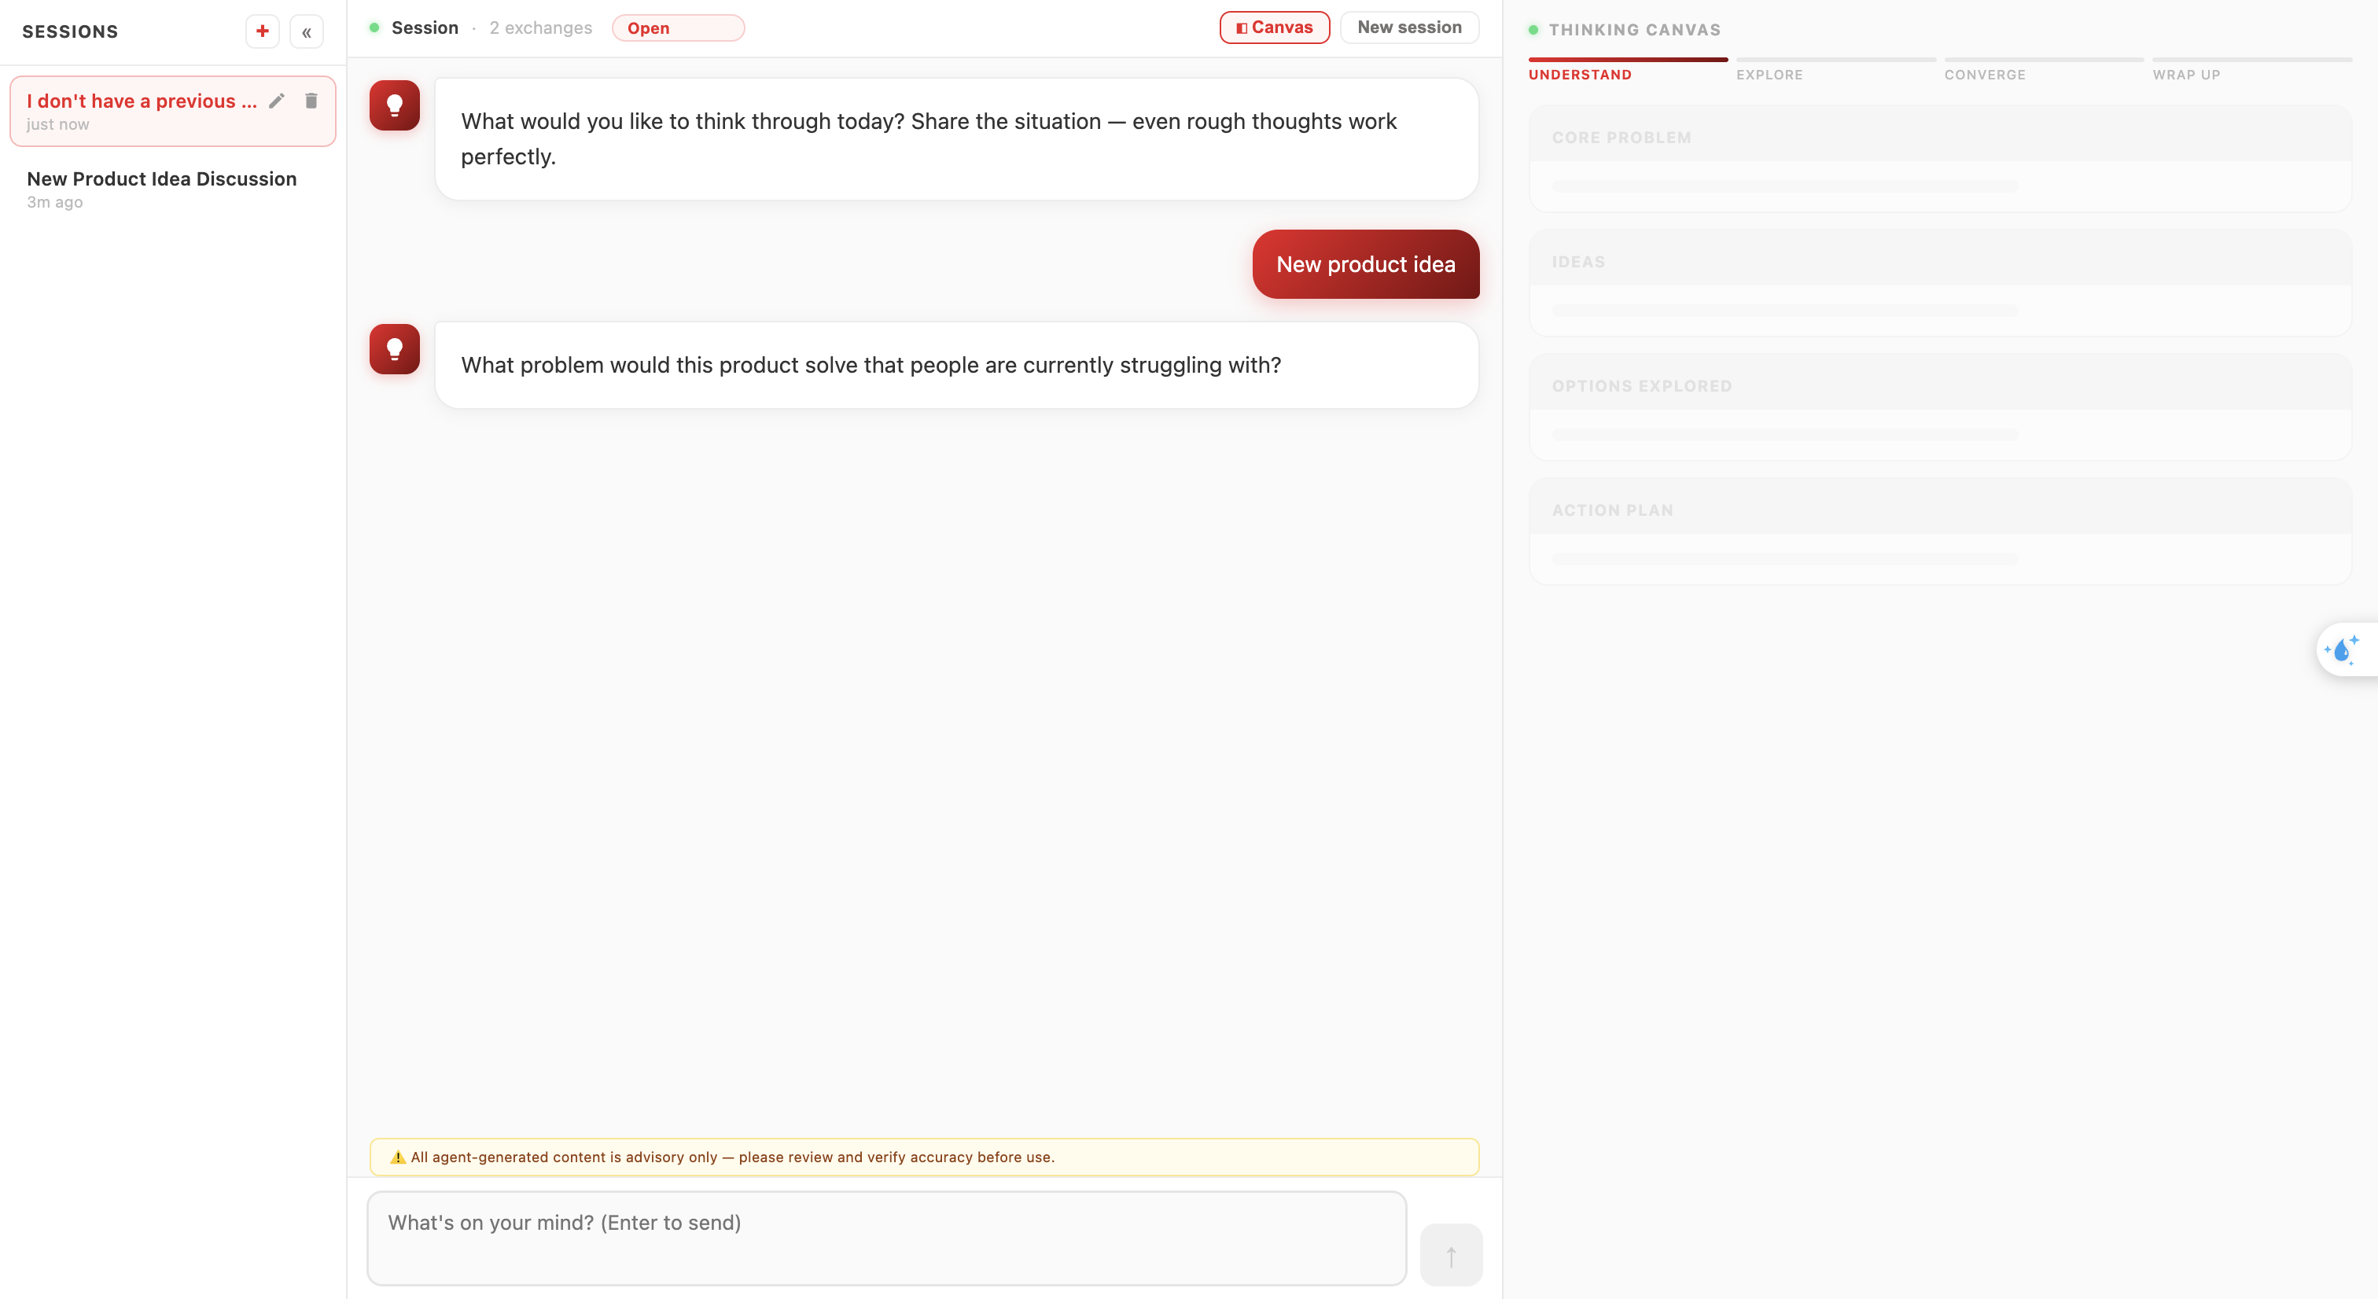
The Brainstormer will ask clarifying questions and guide you through structured thinking. Respond naturally — even rough thoughts work perfectly. The AI adapts to your communication style.
Note:
- At the top of the conversation, click on the current flow to open a dropdown menu displaying available thinking workflows.
- Select a different workflow to adjust how the AI structures its reasoning and responses.
- Any new questions will follow the newly selected workflow.
- Workflows can be switched at any time during the conversation, providing flexibility in how insights are generated.
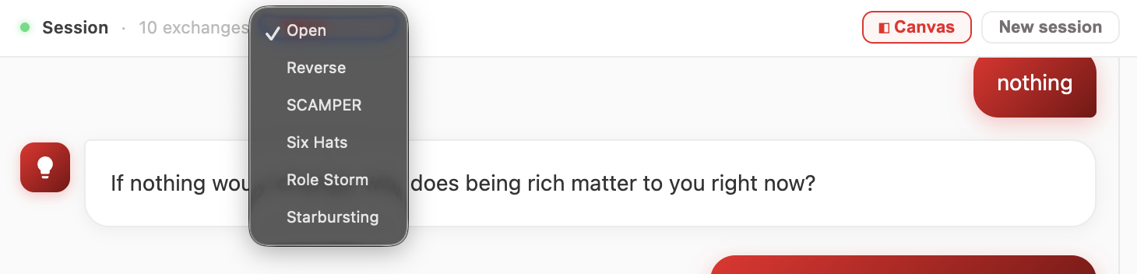

Step 3: Watch the Canvas Build
As the conversation progresses, the Thinking Canvas on the right automatically populates with:
Section | Content
Core Problem | The refined problem statement
Ideas | List of approaches focused on user intent and goals
Options Explored | List of alternatives considered
Action Plan | Concrete next steps
Each section fills in as the AI identifies relevant content from your conversation.

Step 4: Session Completion
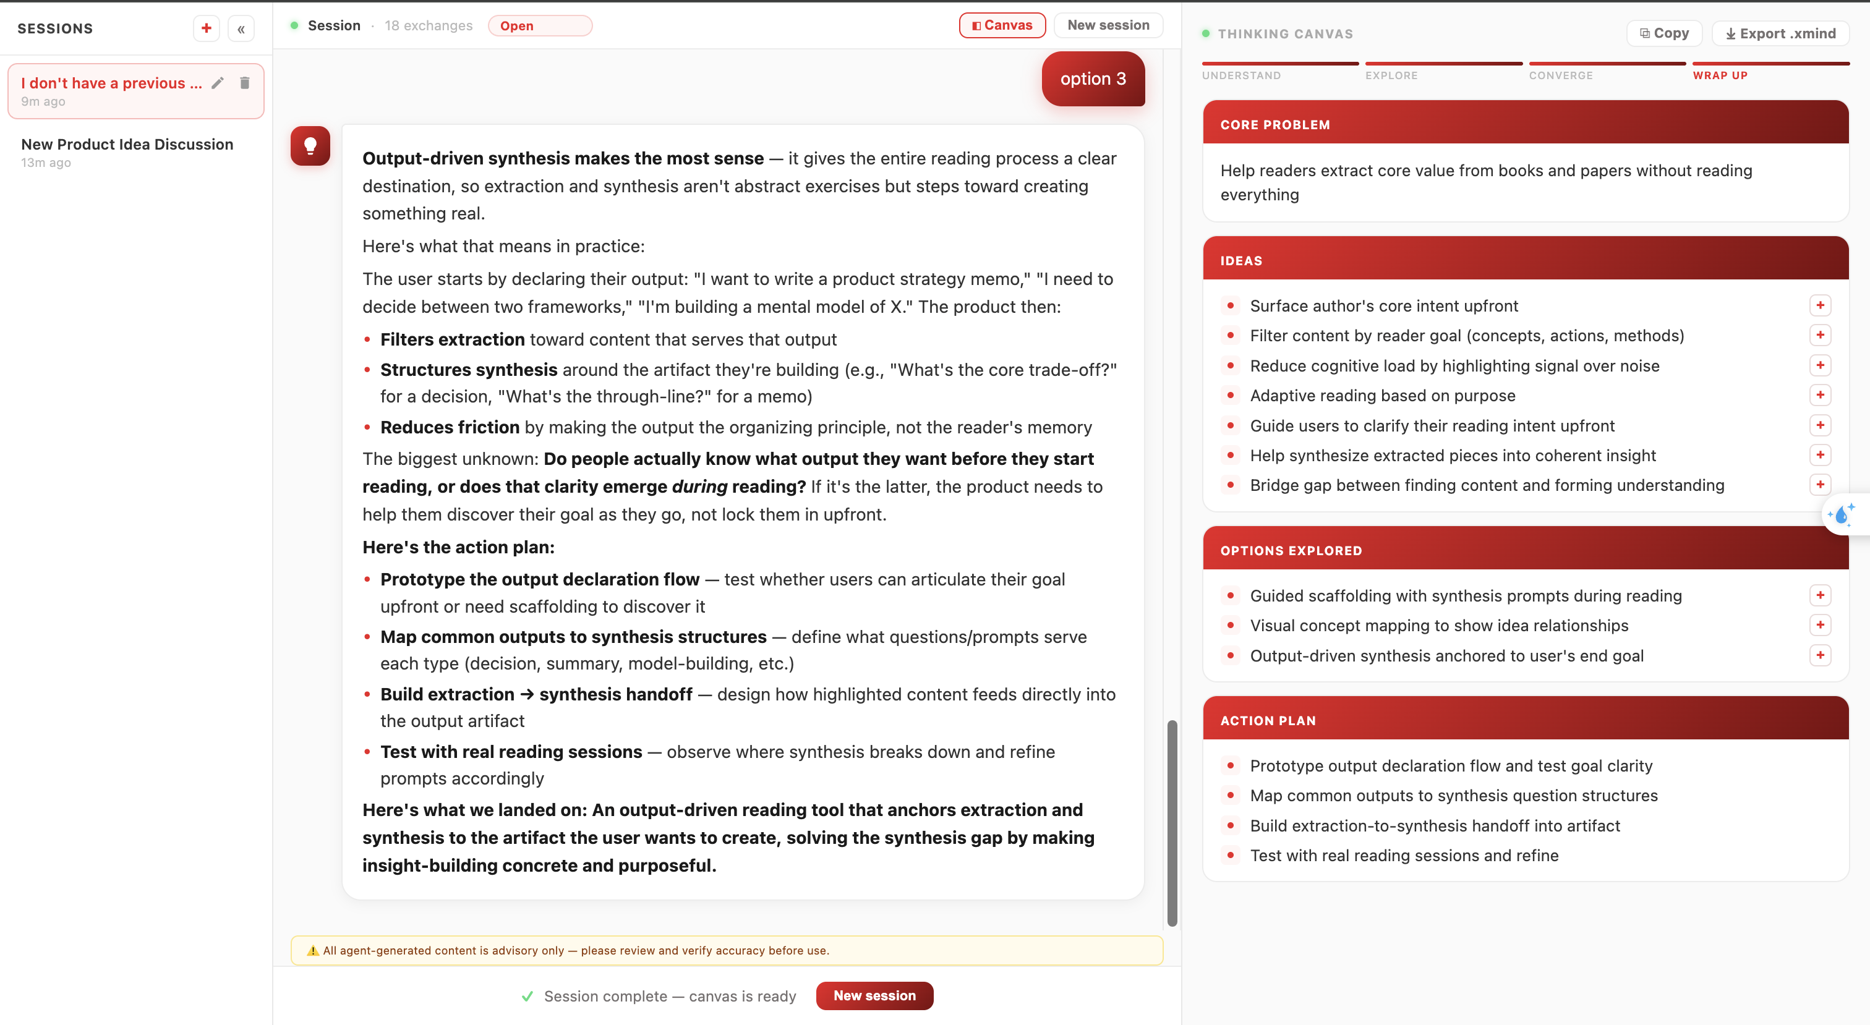
When the brainstorming reaches a natural conclusion, the session is marked as complete:
- A green "✓ Session complete — canvas is ready" message appears
- The input bar is replaced with a "New session" button
- Your canvas contains the final structured output

Output export
At the top-right corner, there are 2 output options:
- Copy Output Content: Copies the full response while preserving its Markdown formatting for easy reuse.
- Export Brainstorming Workflow: Exports the AI-generated ideas and structure into an .xmind file format for mind mapping and further refinement.
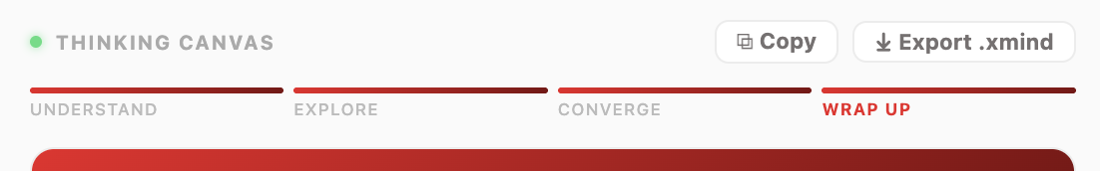

Starting Fresh
Click "New session" in the chat header (or after completion) to start a new brainstorming session with a clean canvas.
──────────────────────────────────────────────────

Features
- Cross-session memory — The Brainstormer remembers your preferences (language, tone, preferred topics) across sessions
- Structured output — Every session produces an organized canvas, not just chat history
- Guided exploration — The AI asks the right questions to help you think deeper
- Session tracking — See exchange count in the header
──────────────────────────────────────────────────

Tips
- Start with a rough idea — the AI will help you refine it
- Be honest about uncertainty — "I'm not sure what I want" is a valid starting point
- The canvas is the deliverable — use it to share your thinking with others
- Multiple short sessions often work better than one long one
- The AI adapts to your language preference over time
- Change the conversation flow anytime during the chat to find the most suitable reasoning style.
──────────────────────────────────────────────────

Limitations
- Long-term memory stores preferences only (language, tone, topics), not full chat history
- Each session is independent — the AI doesn't recall previous session content
- Best suited for strategic thinking, not detailed implementation planning
- No file upload support — text-based interaction only
──────────────────────────────────────────────────
Last updated: 2026-06-22

